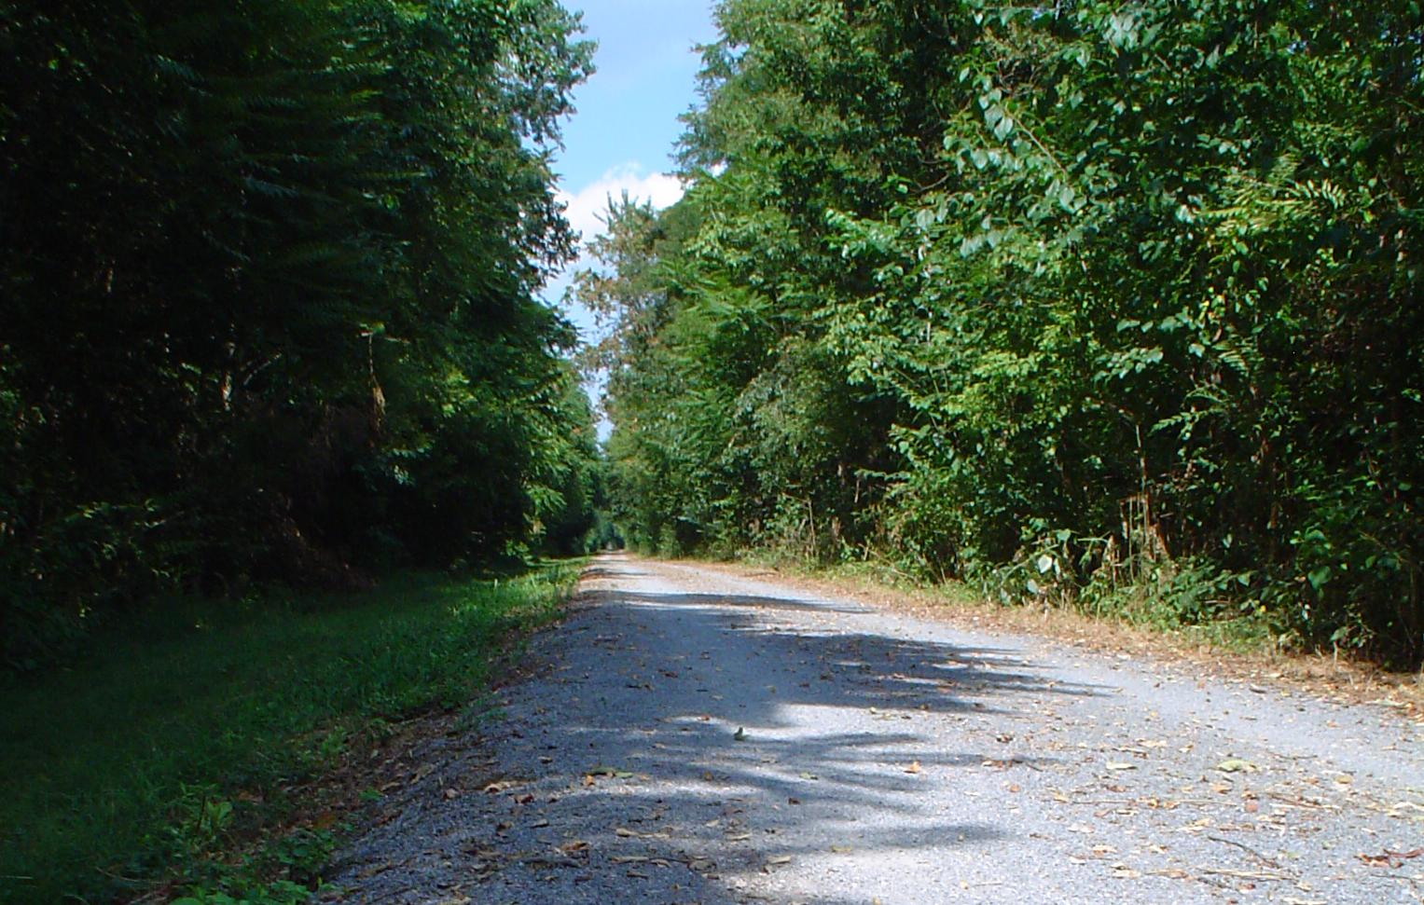

CUMBERLAND VALLEY RAIL TRAIL
2012 USER SURVEY

Prepared by:
Paul Taylor, Ph.D.
Associate Professor
Shippensburg University
Prepared for:
Cumberland Valley Rails-to-Trails Council and South Mountain Partnership
Acknowledgements
This project was financed in part by a grant from the Community Conservation Partnerships Program, Environmental Stewardship Fund, under the administration of the Department of Conservation and Natural Resources, Bureau of Recreation and Conservation.

We are a partner of the South Mountain Partnership, an alliance of organization working to preserve and enhance the cultural and natural assets of the South Mountain Landscape in Central Pennsylvania. This project was awarded through the South Mountain Partnership with management oversight of the Appalachian Trail Conservancy.

To learn more about the South Mountain Partnership visit www.southmountainpartnership.org.

Thanks to the Cumberland Valley Rails-to-Trails Council, for building and maintaining this great trail, and cooperating with this study.
Thanks to Julie Guistwite, Cassie Clarhaut, Alicia O’Donel, Blake Cooper and Sharif Sligh for their assistance in collection calibration data.
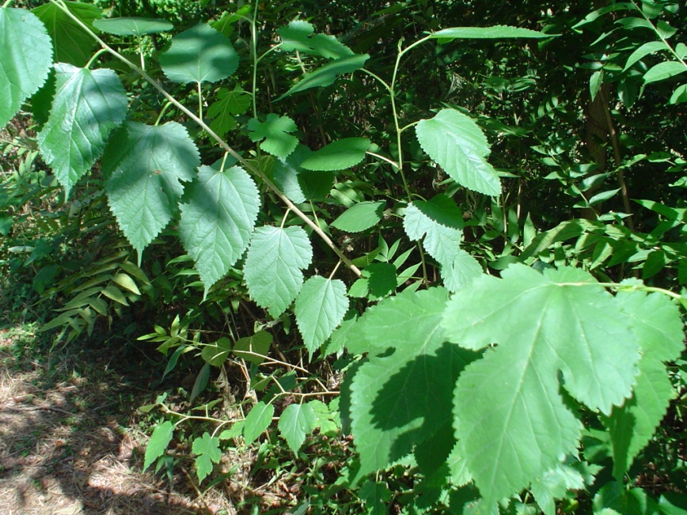
Contents

Executive summary ………………………………………………. | 4
Trail location and map …………………………………………… | 5
Trail user estimate ………………………………………………... | 6
Survey methodology ……………………………………………... | 8
Survey analysis …………………………………………………... | 10
Economic impact …………………………………………………. | 17
Survey results …………………………………………………….. | 19
Future study ………………………………………………………. | 22
References ………………………………………………………... | 23
Appendices:
Circulated survey (paper version) …………………………... | 24
All survey comments ……………………………………….. | 26
User counts – daily averages, weekly and monthly counts …. | 31

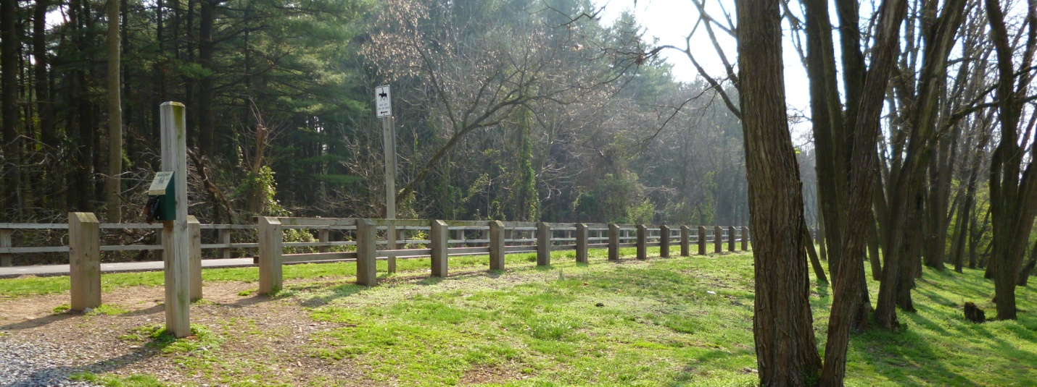
Executive Summary
Based on surveys and infrared counter data collected from February 2012 to December 2012, the Cumberland Valley Rail Trail (CVRT) sees an estimated 40,917 annual visits. These visits result in an estimated economic impact of between $440,000 and $460,000, including direct spending of almost $270,000 by trail visitors.
Background
The Cumberland Valley Rail Trail follows 11 miles of the former Cumberland Valley Railroad from Shippensburg to Newville in Cumberland County, Pennsylvania. 9.5 miles of the trail consist of prepared trail, mostly crushed stone with some sections of pavement. Alongside the crushed stone trail is a dirt trail for horseback riding. There are two primary trailheads, in Shippensburg and in Newville. There is also a smaller trailhead at Oakville near the midpoint. The trail is owned and maintained by the Cumberland Valley Rails-to-Trails Council (CVRTC), an all-volunteer non-profit organization.
Methods
Trail users were counted by three electronic counters placed near each of the three trailheads. These counters operate by sensing the infrared heat signature of passing bodies. They produce very accurate counts, although calculation adjustments must be made to account for people traveling side-by-side or otherwise too close to produce distinct heat signatures.
Surveys were distributed and collected at boxes located at the Shippensburg and Newville trailheads, as well as online. Users were directed to the online form by postings at all three trailheads as well as in the CVRTC newsletter distributed to all members.
Data analysis and survey development were based on trail survey methodology and existing surveys of other rail trails developed by the Rails-to-Trail Conservancy.
Results
While the trail sees a significant number of visitors, it still provides a pleasant level of solitude. On average, daylight hours will see 6-8 users per hour entering at the Shippensburg trailhead, 3-4 entering at Newville and 2-3 entering at or passing through Oakville. At peak hours (Sunday afternoons), 12 at Shippensburg, 8 at Newville and 6 at Oakville would be reasonable estimates.
The most common users are walkers from municipalities neighboring the trail who use the trail regularly, and bikers from a 40 mile radius who ride the entire trail a few weekends each year. The trail also sees regular use by runners and dog walkers. Users typically spend over an hour on the trail and are motivated by a combination of recreation and exercise.
All ages are well-represented. Many users take family or group outings to the trail.
The majority of users were directed to the trail by word of mouth. Some long distance visitors did find the trail through guidebooks and online resources.

Trail Location and Map
The Cumberland Valley Rail Trail is located in south central Pennsylvania, approximately 140 miles west of Philadelphia and 110 miles north of Washington, DC. The trail is located in the Cumberland Valley at the northern end of the Blue Ridge Mountains and within the Chesapeake Bay watershed.
The trail is anchored by Shippensburg (pop. 27,996 ) and Newville (pop. 11,853 ). The population served by the trail extends to much of Cumberland County (pop. 235,406), which contains the entire trail, and Franklin County (pop. 149,618) to the south west.
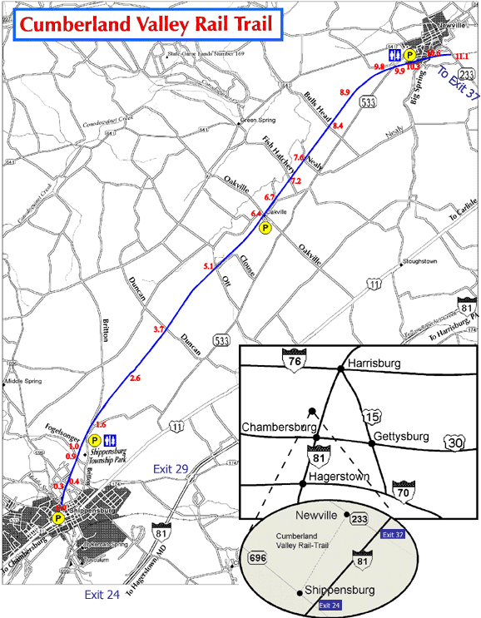(map from CVRTC.org)
Trail User Estimate

From February to December 2012, passive infrared counters were placed at three locations along the Cumberland Valley Rail Trail. These counters record the passing of a warm body and store the data electronically. These counters are very effective, with one primary source of error; if two or more users pass the counter side-by-side, the counter only recognizes one warm signature. Visual counts were collected by volunteers to calibrate for this error, as well as other errors such as users not passing the counter (see Newville counter below).
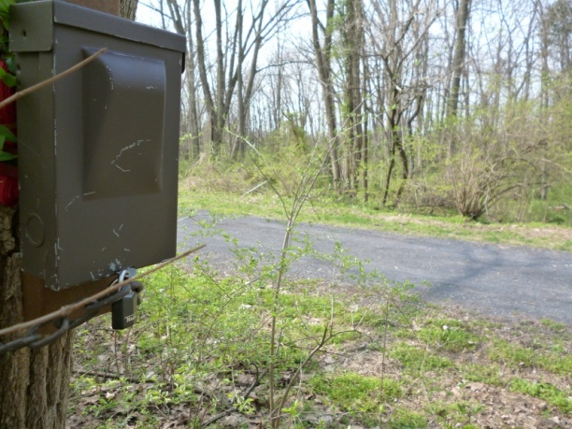
Box containing counter near Newville

Data was downloaded from the counters monthly, at which time the counters were also checked for weak batteries, vandalism and camera blockage due to foliage or insect nesting. The counters operated well throughout the study.
The counters were placed near the trailheads in Shippensburg, Oakville and Newville. All counters were place some distance from the trailhead. This was to avoid double-counting people milling about the trailhead, who might pass the counter several times if it was placed to near the trail entrance. It was also hoped this would make the counter less noticeable, reducing the likelihood of vandalism.
- Shippensburg counter – a counter was placed approximately ¼ mile northeast of the trailhead at Shippensburg Township Park. This distance was selected so as to be short enough to capture all users from the Shippensburg trailhead, but long enough to avoid trailhead activity.
- Oakville counter – the counter at Oakville was moved monthly, alternating between locations ¼ mile southwest and ¼ northeast of the trailhead. This movement was intended to capture users entering at Oakville but proceeding in only one direction from the trailhead, while also capturing all users passing through Oakville. Surveys indicate that few users enter at Oakville, and nearly all the users recorded by the Oakville counter entered the trail at Newville or Shippensburg.
Location | Actual count | Estimated annual count | Divide by 2 for out/back trips | Calibrate for undercounting | Adjust for est. full trail trips
Shippensburg | 37,096 | 40,006 | 20,003 | 31,204.68 | 21,779
Oakville | 13,874 | 14,636 | 7,318 | 11,416.08 | 1,991
Newville | 20,984 | 21,983 | 10,991.5 | 17,146.74 | 7,721
Estimated full trail trips |  |  |  |  | 9,425
Total estimated annual visits |  |  |  |  | 40,917
- Newville counter – the counter at Newville was placed approximately ½ mile southwest of the trailhead. This counter was placed further from the trailhead due the lack of trees near the trailhead, resulting in no suitable location for the counter in the ¼ mile range. Anecdotal evidence indicates some of users entering at Newville would turn back prior to reaching the counter. This discrepancy is accounted for using visual counts for calibration.
Since no data was collected in January or late December, data is extrapolated assuming counts will be similar to early December and February.
After extrapolating, counts were adjusted in two ways. It is assumed that all trips are out-and-back, so users will pass counters twice. The total count is divided by two to adjust for this.
To calibrate for missed users (due to traveling side-by-side or returning before reaching a counter), nine hours of data were visually collected by volunteers. These counts were compared to the counts recorded by the infrared counters. The infrared counters undercounted at a rate typically ranging between 12% and 75%. Total undercounting during the observed hours was 56%, so the infrared counts are multiplied by 1.56 to account for undercounting.

As a side note, volunteers also recorded the activity of observed users. The undercounting tended to be much higher when most users were biking, as opposed to running or walking. It is hypothesized that biking on the trail tends to be a group activity with users often travelling side-by-side, while walkers and runners are more frequently solitary.

In considering the counts, it is also interesting to consider the typical hourly rates. This will give an idea of the user density on the trail; how crowded it will feel, how many other users one is likely to see. The following chart gives the average hourly counts, after adjusting with the undercount calibration.

Even at a peak time and location, it is unlikely that more than 20 users will pass in an hour. Excluding days with special events such as races, hourly counts at the Shippensburg counter did not exceed 25 in July.

Survey – Methodology

The survey form was constructed based on surveys by the Rails-to-Trail Conservancy. Questions were adapted to the particular interests of CVRTC. Trail users could complete the survey either in paper or online. Paper surveys were available at the Shippensburg and Newville trailheads, and surveys could be returned to dropboxes at those locations. Users were directed to the online survey with a link in the monthly CVRTC email newsletter as well as a QR smartphone scan code and web address displayed at the Shippensburg, Oakville and Newville trailheads. The online survey was located at : http://webspace.ship.edu/pttaylor/trailsurvey.html.
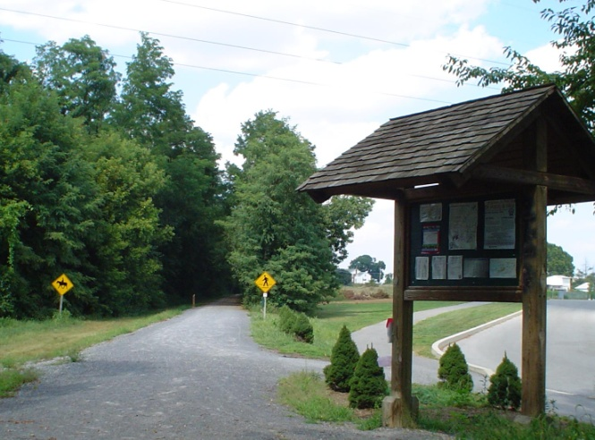Trailhead at Shippensburg Township Park

186 surveys were collected, including 99 submitted online and 87 submitted in paper dropboxes. Respondents were instructed to fill out only one survey for their group, but indicate the number of group members (along with age and sex). The 186 surveys represent data for 475 trail users. In the analysis, results are presented according to percent of surveys, but also weighted by group size on appropriate questions. Some questions are also analyzed weighted by frequency of use. Respondents were encouraged to fill out additional surveys on future visits, but this does not appear to have happened much if at all.

Most of the questions were multiple-choice, although users there were several questions where users could select more than one answer. As such, the percentages on those questions exceed 100% in total.
Since this survey was self-selected, there is the possibility of bias toward certain groups. The results appear in line with anecdotal evidence and surveys of similar trails, with three notable exceptions:
- Shippensburg University (SU) students appear underrepresented in the survey. Anecdotal evidence indicates regular use by SU students, particular ROTC students and student-athletes. Contrary to this observation, the 16-25 year age group is the least represented, by a significant margin. It is hypothesized that SU students were infrequent responders since they travel from campus (survey materials are more accessible to those parking at the trailhead) as well as a general lack of community engagement as compared to other users.
- The respondents use the Newville trailhead in a ratio approximately 2 to 1compared to the Shippensburg trailhead, while the infrared counters indicate the reverse ratio. One likely cause is the lack of response from SU students noted above, since they are a major portion of the Shippensburg trailhead users. Another likely cause is the intense interest in the proposed trail extension through East Pennsboro township to Carlisle, providing extra incentive to Carlisle and Harrisburg users to respond.
- The distance users indicate they proceed down the trail is not in line with anecdotal evidence and infrared counter readings. The Shippensburg trailhead in particular is significantly busier in the first mile. A visit to the interior sections rarely encounters who are not biking the full trail. This discrepancy is likely caused by a correlation between users who are motivated to complete a survey and users who spend more time on the trail.
For comparison, the survey results are compared to results from a 2011 survey of the Lebanon Valley Rail-Trail and Conewago Recreation Trail (the two trails form one continuous path) by the Rails-to-Trails Conservancy. The surveys differ slightly on some question wording and answer options, so comparisons are made when appropriate.

Survey – Analysis
Zip code

35.5% of surveys encompassing 36.8% of users reported living in either Shippensburg or Newville zipcode. These two zipcodes contain the entire length of the trail. A large number of surveys were also received from Carlisle (13.7% of surveys) and West Pennsboro township (7.7% of surveys), which are both along the proposed northeast extension.

The following charts indicates distance to the nearest trailhead as measured by Google Maps. Note, the bar labeled “0” represents Shippenburg and Newville, while other bars indicate the 10 mile range up to the label number (so “30” means zip codes 20-30 miles away).

Frequency of use

A majority of survey responders used the trail only occasionally, twice per month or less. Many of these users were bikers, often groups, from neighboring municipalities. The Lebanon and Conewago trails had a proportion of users who visit the trail at least weekly. (The Lebanon and Conewago survey did not have a “1st time” option.)

Age and gender

The primary age group is 40-64 years, with these users often being accompanied by children 15 and under. Male (51.2%) and female (48.8%) proportions are effectively equal (margin of error is 4-5%). As noted earlier, it is believed that the 16-25 year age grade is underrepresented in this survey, as the trail receives significant use by college students at neighboring Shippensburg University.

The Lebanon and Conewago trail survey only requested the survey responder’s age rather than their group’s ages, so their data excludes many children. They do note however that 17.6% of groups include children 15 and under, compared with 21.7% of CVRT surveys. The Lebanon and Conewago trail survey responders were 55.5% male and 44.5% female, although that could be skewed if a male more frequently completed the survey in mixed groups.

Activities
The primary activities were biking and walking. Biking was the most common selection on surveys, although many bikers were less frequent users. Walkers tended to use the trail more frequently. When scaled for frequency of use, walking has a slightly greater frequency.

The Lebanon and Conewago trail survey only allowed one selection in this question, so the CVRT survey results are scaled for comparison. The responses were very similar between the two surveys when compared this way.

Length of visit

Nearly all responders reported spending at least 30 minutes on the trail during each visit, with about half spending 1 to 2 hours. This distribution is similar to the Lebanon and Conewago trails, and remains similar when scaling for group size. When scaling for frequency, visits between 0.5-1 hour and 1-2 hours are nearly equally common, indicating there are a significant number of users who make frequent shorter visits.

Reason for use

Most users selected both Recreation and Health/Exercise as reasons to use the trail. The Lebanon and Conewago survey only allowed one selection, but had similar results when the CVRT results are scaled to total 100%. The CVRT had slightly more athletic training responses, although the numbers likely under represent Shippensburg University student athletes which are known to use the trail regularly.

Finding the trail

Most users found the CVRT through word of mouth. Perhaps this is not surprising since the CVRT does not pass any major roads, road signage is limited and there has not been much effort to advertise. This may change in the future however, as the CVRT receives increasing press coverage related to proposed extensions and improvements, and athletic events held on the trail increase in popularity.

In contrast, the Lebanon and Conewago trail became known to a large percentage of users who saw the trail or signage from the road. They also reach a significant number of users through their brochure; the CVRT brochure is not widely circulated beyond the trailhead kiosks, although the trail appears in several regional tourism brochures.

Maintenance, safety and cleanliness

The CVRT and Lebanon and Conewago trails have similar results on maintenance, safety and cleanliness. In each category, about 90% of CVRT users rate the trail excellent or good. Ratings in the safety and security category trend lower, which is typical of rail trail surveys. The solitude provided by rail trails is both a positive and negative in this respect. Perception of safety appears to relate directly the density of other users as well as to the visible presence of law enforcement. Some CVRT users also reported unease with youths who sometimes loiter by an overpass approximately ½ mile from the Newville trailhead.

Durable good purchases

59.1% of respondents indicated that the CVRT had influenced the purchase of goods such of a bicycle or athletic clothing. This is less than the rate of 79.8% reported on the Lebanon and Conewago trails. However, CVRT users reported having spent more in the past year, an average of $437.32 among those with purchases, compared with $327.46 on the Lebanon and Conewago survey. Bicycles, bicycle supplies, footwear and clothing were all common purchases.

Consumable good purchases

Respondents were also asked if they made consumable good purchases on their most recent trip and how much they spent per person on that trip. Consumable goods include items such as beverages, snacks and meals. Again, the purchase rate was lower on CVRT than the Lebanon and Conewago trails (41.9% versus 55.5%). The amount spent per person (among those who reported purchases) was slightly lower on CVRT ($11.21 for CVRT, $12.57 for Lebanon and Conewago). Beverages were the most common purchase on CVRT, while snacks were most common on Lebanon and Conewago. In addition, 19.2% of CVRT users reported purchasing a meal near the trail, compared with 13.9% for Lebanon and Conewago.

Portion of the trail most used

The survey responses to this question appear to indicate an underrepresentation of short trail visits (1 mile or less). If the responses were an accurate reflection of trail activity, Oakville should see a similar less of traffic to Newville. However, the infrared counters indicate Oakville receives approximately two-thirds the traffic of Newville. One possible cause for this discrepancy is that responders who vary the distance they travel on the trail reported the longer distances. Another cause could be that short distance users feel less attached to the trail and are less likely to complete a survey.

Comment summary
64.3% of the surveys included additional comments. By far the most common comments were general praise of the trail, thanks for the work of volunteers and the CVRTC, and encouragement and anticipation regarding the proposed extension into Carlisle. There were a number of negative comments, although these were usually more in the way of suggestions than serious complaints and were often accompanied by positive comments.
The following table contains a summary of the comments. Many surveys had several comments, so one survey is often represented in several entries in the table.
POSITIVE COMMENTS | # | % of surveys | % of comments | NEGATIVE COMMENTS | # | % of surveys | % of comments
General positive (nice trail, love trail, beautiful trail, great ride) | 40 | 21.6% | 33.6% | Dog/Horse waste | 9 | 4.9% | 7.6%
Looking forward to Carlisle extension | 26 | 14.1% | 21.8% | Loiterers (usually teens near PA533 overpass) | 8 | 4.3% | 6.7%
Thanks/keep up the good work | 17 | 9.2% | 14.3% | More extension information/website out of date | 7 | 3.8% | 5.9%
Nice scenery/view | 9 | 4.9% | 7.6% | Pets off leash | 6 | 3.2% | 5.0%
Helps community/community asset | 7 | 3.8% | 5.9% | Horseback riders off grass/rude | 6 | 3.2% | 5.0%
Good maintenance | 6 | 3.2% | 5.0% | Want more security on trail | 5 | 2.7% | 4.2%
Will be back | 4 | 2.2% | 3.4% | Want directions to food/food at trailhead | 5 | 2.7% | 4.2%
Looking forward to Shippensburg connector | 3 | 1.6% | 2.5% | Want tent sites | 4 | 2.2% | 3.4%
Grateful | 3 | 1.6% | 2.5% | Trail surface loose | 4 | 2.2% | 3.4%
Nice bathrooms | 3 | 1.6% | 2.5% | Want better signage at trailheads | 4 | 2.2% | 3.4%
Enjoy historical signs/(before signs mounted) would like signs | 3 | 1.6% | 2.5% | Weeds/tall grass | 3 | 1.6% | 2.5%
Like the shade | 2 | 1.1% | 1.7% | Trash | 2 | 1.1% | 1.7%
Good for groups of children | 2 | 1.1% | 1.7% | Tried to travel Newville-Carlisle, not expecting private property | 2 | 1.1% | 1.7%
Like paving at crossings | 2 | 1.1% | 1.7% | Want more pavement | 2 | 1.1% | 1.7%
Car free place to run/bike | 2 | 1.1% | 1.7% | Want more distances markers | 2 | 1.1% | 1.7%
Good races | 1 | 0.5% | 0.8% | Want more restrooms along trail | 1 | 0.5% | 0.8%
Meet nice people | 1 | 0.5% | 0.8% | Dangerous road crossings | 1 | 0.5% | 0.8%
Nice picnic areas | 1 | 0.5% | 0.8% | Rude residents near Newville trailhead | 1 | 0.5% | 0.8%
Nice benches along trail | 1 | 0.5% | 0.8% | Too narrow in spots | 1 | 0.5% | 0.8%
Enjoy nearby businesses | 1 | 0.5% | 0.8% | Excessive bike rules (helmet, daylight) | 1 | 0.5% | 0.8%
Good for dogs | 1 | 0.5% | 0.8% | Want circuit training | 1 | 0.5% | 0.8%
Like surface | 1 | 0.5% | 0.8% | Should advertise more | 1 | 0.5% | 0.8%
 |  |  |  | Would like single track next to main trail | 1 | 0.5% | 0.8%

Economic impact
Economic impact of the Cumberland Valley Rail Trail is estimated using the survey data on purchases of durable goods, consumable goods and lodging, along with the total annual visit estimate of 40,917 obtained from the infrared counter data. Additional impact from items such as new trail construction contracts and maintenance expenditures are not included.
Durable goods
On the survey, 59.1% of respondents indicated making a durable good purchase, spending an average of $437.32 in the past year. Adjusting for group size, these purchases represent 49.7% of users with an average annual expenditure of $203.84 per person. Many of these users visit the trail very frequently, making on average weekly visits. Adjusting for frequency of use, the average annual durable good expenditure is approximately $3.58 per visit.
It is understood that some durable goods are often purchased annually, such as shoes and clothing, while others such as bicycles may be used for 10 years. We assume that the sample includes both users making large infrequent purchases and users between such purchases, so that the average accounts for the long lifespan of goods such as bicycles.
Consumable goods
On the survey, 41.9% of respondents indicated making a consumable good purchase, spending an average of $11.21 per person. Adjusting for group size, these purchases represent 38.3% of users with an average expenditure of $11.92 per person.
Lodging
On the survey, 6.6% of respondents representing 4.7% of users indicated having paid for lodging in connection with their trail visit. However, since out-of-town visitors are not frequent users of the trail, users paying for lodging represented only 0.3% of all trail visits after adjusting for use frequency. This smaller percentage is more accurate than percentage of users for determining total expenditures. The average stay was 2.1 nights at a cost of $68.18 per night. The average expenditure per user was $80.91.
Category | % of users | Average $ per trip | Est. Expenditure
Durable goods | 49.7% | $3.58 | $72,802
Consumable goods | 38.3% | $11.92 | $186,801
Lodging | 0.3% | $80.91 | $9,932
Total annual impact |  |  | $269,535

In addition to this estimate of direct spending, many economic impact studies include indirect spending in their estimates, through use of a multiplier. This multiplier attempts to account for the additional household income and jobs created by the direct spending, and how much added spending in the community will result.
For example, a 2010 economic impact study of the Pennsylvania state parks system used multipliers of 1.65 for lodging and 1.67 for food services in the Dutch Country Roads region (to which the CVRT belongs). These estimated multipliers were obtained using IMPLAN, a widely used economic modeling system developed by the USDA Forest Service. A study of the region surrounding Lewisburg, PA and Bucknell University, which has comparable location and population density to the areas surround the CVRT, used a multiplier of 1.7.
Including secondary effects of indirect spending, the annual economic impact of CVRT is estimated at between $440,000 and $460,000.
To put this impact in perspective, the original trail acquisition and construction cost was approximately $2.5 million, funded mostly by grants from state agencies, primarily PennDOT. Annual maintenance costs are approximately $5000, paid by CVRTC using proceeds from athletic events operated by CVRTC, membership dues and donations.

Survey - Results
Question 2 asked about use frequency and Question 3 asked about group size. Respondents were requested to fill out one survey per group. In addition to percent of surveys, percent of users (surveys weighted by group size) and percent of visits (surveys weighted by group size and use frequency) are included on appropriate questions.

Question 1 – What is your zip code? (Distances estimated using google maps distance to nearest trailhead.)
 | % of surveys | % of users
Shippensburg or Newville | 35.5% | 36.8%
Less than 20 miles | 29.0% | 31.6%
20 to 50 miles | 22.0% | 21.3%
50 to 100 miles | 12.4% | 9.7%
Over 100 miles | 1.1% | 0.6%

Question 2 – How often, on average, do you use the trail?
 | % of surveys | Multiplier for “% of visits”
Daily | 4.8% | 300
3-5 times/week | 12.9% | 200
1-2 times/week | 17.2% | 75
Couple times/month | 25.8% | 25
Once per month | 5.4% | 12
Couple times a year | 14.0% | 2
First time | 19.9% | 1

Question 3 – Please identify the age group and gender of the members of your party.
 | 15 and under | 16-25 | 26-39 | 40-64 | 65 or older
Male | 11.2% | 2.9% | 8.0% | 17.9% | 11.2%
Female | 10.7% | 3.2% | 7.4% | 20.0% | 7.6%

Question 4 – Generally, when do you use the trail?
 | % of surveys | % of users
Weekday | 16.0% | 10.9%
Weekend | 28.7% | 31.5%
Both | 55.2% | 57.5%

Question 5 – What are your activities on the trail?
 | % of surveys | % of users | % of visits
Walking/Hiking/Backpacking | 43.0% | 42.1% | 62.7%
Biking | 72.6% | 73.5% | 56.3%
Running | 22.0% | 25.1% | 38.1%
Dog walking | 15.6% | 12.0% | 20.1%
Horseback riding | 1.6% | 1.5% | 0.0%
Skiing/  snowshoeing | 1.6% | 1.1% | 1.9%
Geocaching | 0.0% | 0.0% | 0.0%

Question 6 – How much time do you generally spend on the trail?
 | % of surveys | % of users | % of visits
Under 30 minutes | 0.5% | 0.4% | 0.6%
30 minutes to 1 hour | 18.8% | 21.9% | 40.5%
1 to 2 hours | 52.2% | 50.3% | 42.9%
More than 2 hours | 28.5% | 27.4% | 15.9%

Question 7 – Would consider your use of the trail to be for…
 | % of surveys | % of users | % of visits
Recreation | 70.4% | 67.8% | 54.1%
Health/Exercise | 84.4% | 77.3% | 77.3%
Commuting | 2.7% | 1.9% | 2.7%
Training | 12.9% | 15.8% | 19.4%
Other | 0.0% | 0.0% | 0.0%

Question 8 – How did you find out about the trail? (Rail Trail resources were write-in answers, part of “other”.)
 | % of surveys | % of users
Word of mouth | 53.8% | 58.5%
Bike shop | 2.2% | 1.9%
Parks Department | 3.2% | 2.3%
Website | 14.5% | 11.4%
Saw trail/sign from road | 9.1% | 9.1%
Newspaper | 4.8% | 4.4%
Visitors bureau | 0.5% | 0.2%
Rail Trail resources | 5.9% | 5.9%
Athletic event | 2.7% | 2.3%
Other | 2.7% | 2.3%

Question 9 – Has your use of the trail influenced your purchase of:
 | % of surveys
Bike | 29.7%
Bike supplies | 30.8%
Auto supplies | 4.1%
Footwear | 24.4%
Clothing | 25.0%
Nothing | 40.7%
Other | 8.1%

Question 10 – Approximately how much did you spend on the above items in the past year?
110 surveys (59.1%) including 236 people (49.7%)indicated a purchase. The average dollar amount for those who indicated a purchase was $437.32 per survey and $203.84 per person.
Question 11 – In conjunction with your most recent trip to the trail, did you purchase any of the following:
 | % of surveys
Beverage | 29.7%
Candy/Snack foods | 20.3%
Horse rental | 0.0%
Meal at a restaurant near trailhead | 19.2%
Nothing | 59.3%
Other | 0.0%

Question 12 – Approximately how much did you spend, per person, on the items above on your most recent visit?
78 surveys (41.9%) including 182 people (38.3%) indicated a purchase. The average dollar amount for those who indicated a purchase was $11.21 per survey and $11.92 weighted by group size (note the question specified per person).
Question 13 – Did your visit to the trail involve an overnight stay?
 | % of surveys | % of users | % of visits
Yes | 6.6% | 4.7% | 0.3%
No | 93.4% | 95.3% | 99.7%

Of the 12 surveys indicating an overnight stay, the types of accommodations were 2 tenting, 2 camping, 6 hotel and 2 house rental. They stayed for an average of 2.1 nights and an average nightly cost of $68.18.
Question 14 – In your opinion, the maintenance of the trail is
 | % of surveys
Excellent | 49.7%
Good | 42.7%
Fair | 5.9%
Poor | 1.6%

Question 15 - In your opinion, the safety and security along the trail is
 | % of surveys
Excellent | 41.5%
Good | 47.0%
Fair | 7.7%
Poor | 3.8%

Question 16 - In your opinion, the cleanliness of the trail is
 | % of surveys
Excellent | 58.9%
Good | 34.6%
Fair | 3.2%
Poor | 3.2%

Question 17 – Which trail access point do you generally use when you visit the trail?
 | % of surveys | % of users
Shippensburg | 38.6% | 35.8%
Oakville | 3.8% | 5.9%
Newville | 57.6% | 58.3%
Other | 0.0% | 0.0%

Question 18 – What portion of the trail do you use most often? (Respondents gave access point and turnaround point. The table below represented the percent which included each landmark.) Last column weighted using counter data to adjust for bias toward Newville trailhead.
 | Mile Marker | % of surveys | % of visits, weighted
Earl St | 0 | 11.0% | 10.0%
Shippensburg | 1 | 72.1% | 80.5%
Britton Rd | 1.6 | 71.5% | 79.3%
Duncan Rd | 3.7 | 69.2% | 72.9%
Ott Rd | 5.1 | 69.2% | 59.3%
Oakville | 6.4 | 73.3% | 55.8%
Fish Hatchery | 7.2 | 66.9% | 43.7%
Nealy Rd | 7.6 | 69.2% | 45.1%
Bull's Head Rd | 8.4 | 75.6% | 44.6%
Fry Rd | 9.8 | 80.2% | 45.8%
Newville | 10.3 | 80.8% | 46.2%
Big Spring Rd | 10.6 | 8.7% | 1.1%

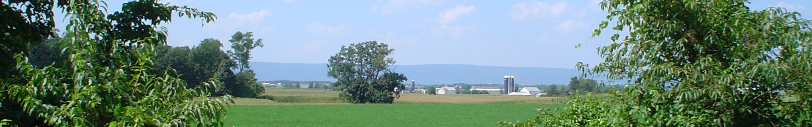
Future study
A wealth of data was collected for this study and the analysis presented here only represents an initial summary. Further analysis, combined with other data such as weather patterns, could extract much more information about CVRT users. Some examples of possible future analysis:
- The 2011-2012 winter was particularly mild. Counts could be correlated to temperature, then used to estimate annual counts for a year with average temperatures.
- The effect of precipitation or sunshine on user counts could be studied.
- Visual data could be collected to estimate the proportion of Shippensburg trailhead users in the 16-25 age range. This data could then be used to correct for the apparent underrepresentation of this age group in the survey data.
- In future years, visual counts could be collected over short periods of time. This data could then be used to extrapolate annual user rates using the usage patterns collected in this study. Such visual data has already been collected for 2010 and 2011 (approximately 50 hours each year).

References
Mowen, Andrew J., Alan R. Graefe, Nate E. Trauntvein and Daniel J. Stynes, “The Economic Significance and Impact of Pennsylvania State Parks.” Pennsylvania Department of Conservation and Natural Resources, updated February 2012. Retrieved from http://www.dcnr.state.pa.us/ucmprd2/groups/public/documents/document/dcnr_007019.pdf.
National Bicycle and Pedestrian Documentation Project, “NBPD Adjustment Factors.” Accessed March 2009. Retrieved from http://bikepeddocumentation.org/index.php/download_file/-/view/11
Nelson, Charles, Joel Lynch, Christine Vogt and Afke van der Woud. “Use and Users of the Pere Marquette Rail-Trail in Midland County Michigan.” Department of Park, Recreation and Tourism Resources, Michigan State University.. Retrieved from http://www.carrs.msu.edu/trails/Reports/PM_TRAIL_USE_REPORT2.pdf.
Oswald, Michelle, Thomas Kinnaman, Kelly Burkhart and Mike Nicholson, “Buffalo Valley Rail-Trail 2012 User Survey and Economic Impact Analysis.” August 2012. Retrieved from http://bvrt.org/2012-BVRTUserSurveyEconomicImpactAnalysis.pdf.
Rails-to-Trails Conservancy, “Trail User Surveys.” Accesed July 7, 2011. Retrieved from http://www.railstotrails.org/ourwork/trailbuilding/toolbox/informationsummaries/trailuser_surveys.html.
Rousu, Matthew C, “The Economic Impact of Bucknell University on the State of Pennsylvania and the Six-County Region During the 2009-2010 Academic Year.” 2010.
Tomes, Patricia and Carl Knoch, “Lebanon Valley Rail-Trail and Conewago Recreation Trail 2011 User Survey and Economic Impact Analysis.” Rails-to-Trails Conservancy, January, 2012. Retrieved from http://www.railstotrails.org/resources/documents/ourWork/reports/Lebanon%20Valley%20and%20Conewago%20Recreation%20Trails.pdf .
Tomes, Patricia, Carl Knoch, Karen Stewart and Jennifer Barr, “Trail User Survey Workbook.” Rails-to-Trails Conservancy, 2005. Retrieved from http://www.railstotrails.org/resources/documents/resource_docs/UserSurveyMethodology.pdf.
Cumberland Valley Rail Trail User Survey

In order to provide you with a high quality recreational experience, we are conducting a survey of trail users. One survey form per group, but please complete new surveys on future visits. Survey results will be kept anonymous. Do not include your name, address or similar identifying information.
Complete the survey online: http://www.cvrtc.org/survey.htm
In completing and submitting this survey, you are agreeing to release the information to the Cumberland Valley Rails-to-Trails Council (CVRTC), Shippensburg University and the South Mountain Partnership.
To learn more about the CVRTC, or to join or donate, visit www.cvrtc.org and www.crvtx.org.
To learn more about the South Mountain Partnership visit www.southmountaincli.blogspot.com.

CHECK ALL ANSWERS THAT APPLY

1: What is your zip code? _____________

2: How often, on average, do you use the trail?
O Daily O 3-5 times/week O 1-2 times/week O Couple times/month O Once per month O Couple times a year O First time

3: Please identify the age group and gender of the members of your party.
Age Group | 15 and under | 16 to 25 | 26 to 39 | 40 to 64 | 65 or older
# of
male(s)
# of female(s)

4: Generally, when do you use the trail?
O Weekdays O Weekends O Both

5: What are your activities on the trail?
O Walking O Biking O Running O Dog walking O Horseback Riding O Skiing/Snowshoeing O Geocaching O Other activity (specify) __________

6: How much time do you generally spend on the trail?
O Under 30 minutes
O 30 minutes to 1 hour
O 1 to 2 hours O More than 2 hours

7: Would you consider your use of the trail to be for…
O Recreation O Health and Exercise O Commuting O Athletic Training
O Other (specify) __________________

(continued on other side…)

This project was financed in part by a grant from the Community Conservation Partnerships Program, Environmental Stewardship Fund, under the administration of the Department of Conservation and Natural Resources, Bureau of Recreation and Conservation. We are a partner of the South Mountain Partnership, an alliance of organization working to preserve and enhance the cultural and natural assets of the South Mountain Landscape in Central Pennsylvania. This project was awarded through the South Mountain Partnership with management oversight of the Appalachian Trail Conservancy.

8: How did you find out about the trail?
O Word of mouth O Bike shop O Parks Department O Website O Saw trail/sign from road O Newspaper O Visitors Bureau O Geocaching O Athletic Event O Other ______________

9: Has your use of the trail influenced your purchase of:
O Bike O Bike supplies O Auto accessories O Footwear O Clothing O Nothing

10: Approximately how much did you spend on the above items in the past year? $______________

11: In conjunction with your most recent trip to the trail, did you purchase any of the following:
O Beverages O Candy/Snack foods O Horse rental O Meal at a restaurant near trailhead O Nothing
O Other ______________

12: Approximately how much did you spend, per person, on the items above on your most recent visit? $____________

13: Did your visit to the trail involve an overnight stay?
O Yes O No
- If “Yes”, please specify:
Type of accommodations __________
Number of nights __________
Approximate cost per night _______

14: In your opinion, the maintenance of the trail is
O Excellent O Good O Fair O Poor

15: In your opinion, the safety and security along the trail is
O Excellent O Good O Fair O Poor

16: In your opinion, the cleanliness of the trail is
O Excellent O Good O Fair O Poor

17: Which trail access point do you generally use when you visit the trail?
O Shippensburg Township Park
O Oakville O Newville
O Other (please specify) ________

18: What portion of the trail do you use most often? (connect from access point to typical turnaround point)
Earl  St. | Shippensburg  Trailhead | Britton  Rd. | Duncan  Rd. | Ott  Rd. | Oakville  Trailhead | Fish  Hatchery | Nealy  Rd. | Bull’s  Head | Fry  Rd. | Newville  Trailhead | Big Spring  Rd.
O | O | O | O | O | O | O | O | O | O | O | O
Mile 0 | 1.0 | 1.6 | 3.7 | 5.1 | 6.4 | 7.2 | 7.6 | 8.4 | 9.8 | 10.3 | 10.6

19: Additional comments:

All survey comments
Love the trail..only comment..think they could mow the grass on the trail more often.
love the trail; it s a great asset to the region and community
too many pets off leashes and horse manure on the stone part of the trail.
trail is really nice. But the other day we had to deal with someone under the bridge at the trailhead being less then nice and make rude comments. did not make me feel safe or my running partner.
when is the trail going to make it to carlisle? newville residents at the trailhead are not the nicest people and i would love not to go out there for my walk.
200 meter markers would be nice for sprints and pace estimating.
5 star trail
A great ride!
A piece of parallel single track would be a fantastic addition.
A real bathroom! Thank you! How nice.
absolutely love the trail, cant wait till the carlisle extension is opened, keep up the great work, only one issue, not your frault, but many dog owners dont pick up after their dogs, please start warning them to do so
Additional signage is needed to remind people to leash their dogs. There are too many dogs roaming unrestrained.
almost always have a good time on the trail. this past weekend there was a good amount of kids on the trail that were being very rude and cussing. i was embarrased to have my children out on such a nice day. what can be done for better control of what happens on the trail?
Are there places to buy a healthy lunch? We know about Dollar General… Thanks - cannot wait for completion!
Beautiful views from Shippensburg to Newville. Nice intersections!
Can anyone do something about the people who camp out under the over pass at the trailhead in Newville or is that something for the local police?
Can t wait for the trail to Carlisle to begin!
Certain trail rules should be more prominent at each access point along the trail, especially the one about DOGS SHOULD BE ON A 6 FOOT LEASH and UNDER CONTROL. I have seen way too many unleashed dogs wandering about the trail in the vacinity of their owners. Ninety to ninety-five percent of owners do have their dogs leashed and under control. A friendly dog can be just as dangerous to a walker/runner/biker by causing them to trip or wreck. Just a couple weeks ago, while biking I came across a woman riding a bike with her dog running near by. I approached from behind and rang my bell numerous times when I neared. Of course the dog heard me way before the woman and came at me growling and snapping. Thank goodness for my reflexes (I jumped off and put my bike between me and the dog) or she may have had a law suit on her hands. How stupid can anyone be to think that they could control a dog on a bike! One of my expense items (survey question #10)is to purchase a can of pepper spray just in case I come across anymore aggressive unleashed dogs and/or stupid dog owners. BTW I really love the trail. Thanks so much for providing such a scenic and pleasureful place to spend some time away from the real world!
crossing can be dangerous some are pretty blind in the turns. one of our members isnt the fastest and we had some close calls with speeders.
CVRT is a beautiful ride and very well maintained. I ve also met alot of nice people out there.
CVRT is an great resource and an excellent investment.
Excellent job maintaining the trail, great running events 3x a yr, and we really enjoy the serenity of the surroundings.
Going north, the cinders on the right side are very thick and pose a sliding problem, plus it's difficult to ride there - there's a drag on your bike. The left side is more firm, but we must go single file and move out of the way as people come towards you. Don't know what to suggest - maybe right side has too much - too thick of cinders. It's a beautiful ride!
Good trail! Map in Newville needs a "you are here" arrow. No way to tell how to get to services! Keep working and get it extended! Center of the trail needs some weed killer to keep the grass and weeds down.
Great idea. Best way to give back to the taxpayers where everyone gets use of it and improves family and community. Thank you
Great job! Thanks.
Great job! Thanks.
Great trail we will be back. beautiful scenery.
Happily looking forward to the extension to Carlisle!
Hope the CVRT extends through Plainfield.
Horse users need to have better education about acceptable usage on the trail. Also, dog owners need to be more careful of keeping their pets on a leash and understanding that others there are not coming for a dog show.
I am the coach of the high school XC team and it provides us with a safe place to train.
I enjoyed reading the historical signs. I hope you're successful in extending it to Carlisle; if so I'll be back.
I gave the rating of "fair" for cleanliness because of the amount of dog owners that do not pick up after their pets. I am a dog owner and do clean up after him. It is a health issue. I don t want dog feces on the bottom of my shoe and I don t want worms or disease to passed from someone elses unvaccinated dog to my pet. I would suggest posting signs reminding people that it is their responsiblity to clean up after their pet and encourage trail users to speak up if they see someone not fulfilling their obligation.
I like the paved intersections.
I m not sure exactly where you prefer horsetrailer parking at Newville Trailhead. Are we to try to back in or park parallel to the street? We try to use the trail when fewer bikes are on it because they tend to come flying up behind the horses with no warning which is dangerous to all involved.
I rode bikes with our local scout troop #185 yesterday (from Huntsdale) and hope that this becomes an annual event. The experience could not have been better with perfect weather and a very well maintained trail and restroom facilities. It may spark some interest with our boys to earn the cycling merit badge in the future!!
I think I biked the entire trail from Newville to Ship and back. Unfortunately no signage told me how to get to town and when I finally found the way there wasn't much to buy. Please add signage at Ship end directing people to businesses.
I think its great for all ages and I love it! My grandog loves it too!
I think with the warm weather the teenagers are having too much fun on the trail. noticed some "safe sex" items along the trail. On the bright side they are thinking first.
I use this trail mostly to commute to school, but often use it for recreation.
I was planning a trip and needed an overnight stop in the general area. Finding the trail on the rail to trails site was the determining factor in picking yhe shipping hotel. I was disappointed when the trail out of town petered out at a steep down hill at fogelsanger road, and turned around and went back to the hotel. I looked at the maps and headed out with my car to try to stumble into the trail later. At this point it seemed like an incomplete trail, and there was a warning sign in town. Happily I found the ball field, and turned in hoping to find access to the path. I found it and had a nice ride. I have also made a reservation to stay again later this week, as I head home, specifically to bike. The town of shippers burg is the natural entry to the trail, particularly for visitors, so it is a shame it ends at fogelsanger road. Your highest priority should be to bridge the road, or create sone switch back ramp system on each side. The easy recommendation is a sign at the park entrance saying that there is access to the rail trail.
i would like there to be more information about the extention availble. we heard alot at one time but nothing since.
I would like to see some "blue light" security posts--- like on college campus, that if needed, a person can summon emergency workers. As a young mom, I m not likely to go there by myself because it feels so secluded. I would use the trail daily if I saw police officers or park rangers, or someone official looking wandering around or the trail had some kind of security measures.
I would love to see bridges built over Fogelsanger Rd and Big Spring Rd in order to allow easier bike access to the areas beyond those roads.
I would love to see the trail extended to Carlisle!
It's usual shady from the many trees, keeps it coller in summer. Like having a bathroom close. We live 6 mile from trail + we love it!
Just finished the trail. Did it in fits & pieces over last yr + 1/2. A beautiful trail you folks can be proud of. Hope it gets to Carlisle. Thanks for all your hard work.
Keep this trail up! This society needs this!!
Keep up the great work!
Like to see it in Carlisle. Change of scene. Thanx.
Love it! Just a half hour from home, and a lovely way to spend time with my spouse!
Love the trail!
Love the trail!
Love the trail. Was extremely excited about plans to join at Carlisle.
Love this trail! So peaceful and close to our home. Looking forward to the extension to Dickinson!
My husband and I love this trail and would love to see it expanded. We actually go more than a couple times a year. Just don t go in the winter.
need to have food stands or something at the trailheads. also, it would be nice to have areas to camp along the path, since the trail is going to be over 22 miles long soon. I think that would bring in many long distance hikers, bikers and campers.
Needs to go up to Carlisle!
nice trail. highly recommend it. hope to see you expand it to harrisburg
nice trail. website is very outdated. it needs more current information. some at my work said that the rail goes from newville to carlisle but the website says it stops in newville. would recommend information signs along the trail for history buffs. but nice trail
nice weekend to be on the trail. it would be nice if your website had a blog so people can help in keeping an eye out for issues on the trail. i have seen it used in other cases and it helped alot with security. plus it seems like you have some people that think the trail belongs to them. Had our kids along and had to deal with some rude teenagers using bad words around my kids. other then those few times its a very nice trail.
not the best for hiking. difficult to camp since you have no assigned camping spot. more of a yuppie trail then a real trail
On beautiful days like today, could have used an outhouse or porta pot along the trail so we wouldn’t have had to go in the woods instead of cutting our trip short
On my last hike I decided to check the trail surface. Need more info on Oakville and Newville (Restaurant or Conv Store).
on our most recent trip our group noticed some people camping or some drifters living on the trail and found smoking products and what looked like a condomn on the side of the trail.
once the new section is complete you should make sure to add some camping sites along the way for overnite stays.
Please extend to Carlisle!
Please make it longer - into Carlisle! Love my trail! Thank you!
Pretty nice trail.
really good trail with a nice view
really nice trail. gets very narrow in some spots. should be wider so when the mennonites are riding 4 or 5 accross on bikes they dont push you to the side when walking.
Recently I was checking out the new section of trail that was purchased and was rudely greeted by someone who said I was trespassing on his property. Someone needs to make sure that these people know they don’t own the old rail road ground. If you didn’t know it, some of them have made it impossible to walk the trail without jumping fences.
Right side of the trail from Shippensburg to Newville was a little soft. The left side was much firmer. Would like to see it cotinue to Carlisle. Thanks.
Safety is a concern for me as a female. The portion of the trail from Newville to Oakville is very remote and isolated. I don t run this portion alone.
Since the property is private land. can you do anything to stop smoking on the rail and loitering. we came across some teenage kids smoking and acting bad when our family was out this past weekend.
Some equestrians do not follow the trail rules and subsequently damage the crushed stone surface.
Surface is not properly compacted, especially from Shippensburg to Oakville. Weeds have grown in and trail is narrowed. Would love to see improvements start happening!
Thank you, we love it! I would like a short poster about the history of the rail. And maybe some interesting historic spots along the way.
The last two Sundays we encontered people riding horses on trail instead of the grass and Horses crapping on trail.When asking rider to ride on grass She called us big mouths and She didnt care.
The only suggestion I would have is more even distribution of crushed gravel. . It was a little thick in places necessitating we ride on the left side of the trail as we headed from Shippensburg to Newville. Otherwise, great!!!
The Rail to Trail has provided a beautiful and safe environment to return to the sport of biking. Thank you to all who have a part in maintaining the trails.
This trail is a terrific asset to the community and I really appreciate it. My goal this summer is to start using it once per week.
too much dog and horse manure on the trail. Rude people on horseback on the stone trail
Usually bike the C+O canal and the rail-trail at Hancock, MD, and sometimes the WO+D trail in VA. First time, here, like it a lot, will be back with family more often. NOT ADVERTISED - lucky I found it on internet.
Very enjoyable. Well planned.
Very nice trail, the fact that most is in the shade is a plus, great views of mountains and beautiful farmland, the recent addition historic signs is great.
We are new to the area. Live in Carlisle and my husband works at Volvo in shippensburg. He and a coworker last week commuted to work from newville. They hope the trail is extended to Carlisle so they can bike the whole way.
We are so fortunate to have such a fantastic resource available to us. Hope the expansion to Carlisle comes soon!
We are very glad the trail is there. It has helped us a lot.
We do a lot of cross country hiking it was difficult to find a place to set up a tent for the night. Could the trails set up some tent sites along the way for us distance hikers?
We enjoy your beautiful trail. Saylor Market is also a fun place to visit with their nice food bar.
we like to travel the rail to trail system and run. this one is pathetic. we heard all kinds of good things about it from others. when we ran it, we had to deal with horse crap on the trail, groups of teens riding bike taking up all the path. horses on the path. dogs running loose. must say i am not impressed. it seems more of a short cut for trouble makers then a recreation area. take some pride in the land you own, we hope you dont screw up the other section you bought and make this into a 22 mile drifter highway. like the first section is.
We live in Newville. The trail is beautiful and we plan on coming back regularly.
We ride this ourselves as well as bring bike club rides. The pavilions are a great place for a picnic at our turning point. We are anxious to see how the Carlisle extension develops and were interested to hear discussion of a future possible Chambersburg connection. A good connection to the university may make bicycle commuting to school a real option.
We usually do an out and back from Newville to Shippensburg or visa versa. Trail is a wonderful gem!
We would love to see the trail continue through to Carlisle, although we understand the landowners reluctance to relinquish part of their land. This is a great trail! :-) Thank you!
website is outdated. should keep things better posted on the progress of the new section.
While overall a nicely maintained trail, your ridiculous rules about night use and helmets are offputting. I arrived at the trail via Bullshead Rd. while on a 75 mile ride following directions provided by Google Maps, without a helmet. I rode your trail anyway and, get this, didn t die of head injuries. I do recall, several years ago during the planning stages of your trail, that the idea of commuting between Shippensburg and Newville was tossed around. I thought this was a wonderful idea. Continuing the trail to Carlisle would also be wonderful for those who live in Ship or Newville and work in Carlisle. What if their work shifts don t align with daylight hours? How strictly would you be willing to enforce your "no riding after dark" rules? Would you actively try to prevent someone like me, who has a very expensive and bright lighting system, from using the trail to get to my job? Do you think I d be better off on a road shared with motor vehicles after dark? I really think you should re-evaluate your rules and try to bring them in line with the current PA vehicle code regarding bicycles. Until you ve managed to do that, I ll be avoiding your trail. I ve donated to other trail systems in the past and when I do so in the future it won t be to yours.
Will be back!
Wonderful bathrooms! Thanks.
wonderfull trail !!!!
Would like the trail to extend to Carlisle.
Would like to see addtion of work out stations every 1/2 mile on trail. I would be willing to help raise funds.
Would like to see more distance markers between mile markers
Would like to see trail paved. Would like bridge to access Shippensburg.
Would prefer paved surface. Felt cautious being alone. Grateful to have it here!

Users counts – daily averages (not adjusted for undercounting)

Weekly user counts (not adjusted for undercounting)

Monthly user counts (not adjusted for undercounting)

Shippensburg zipcode 17257 population, 2010 US Census
Newville zipcode 17241 population, 2010 US Census

