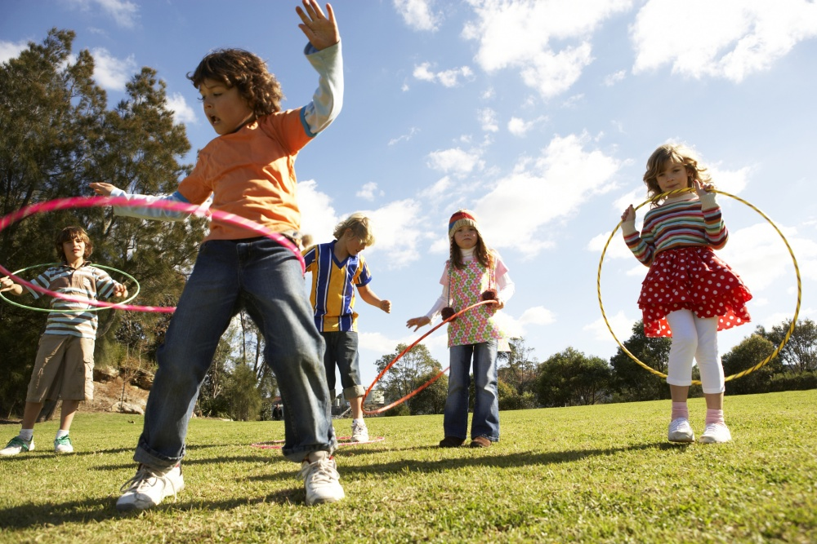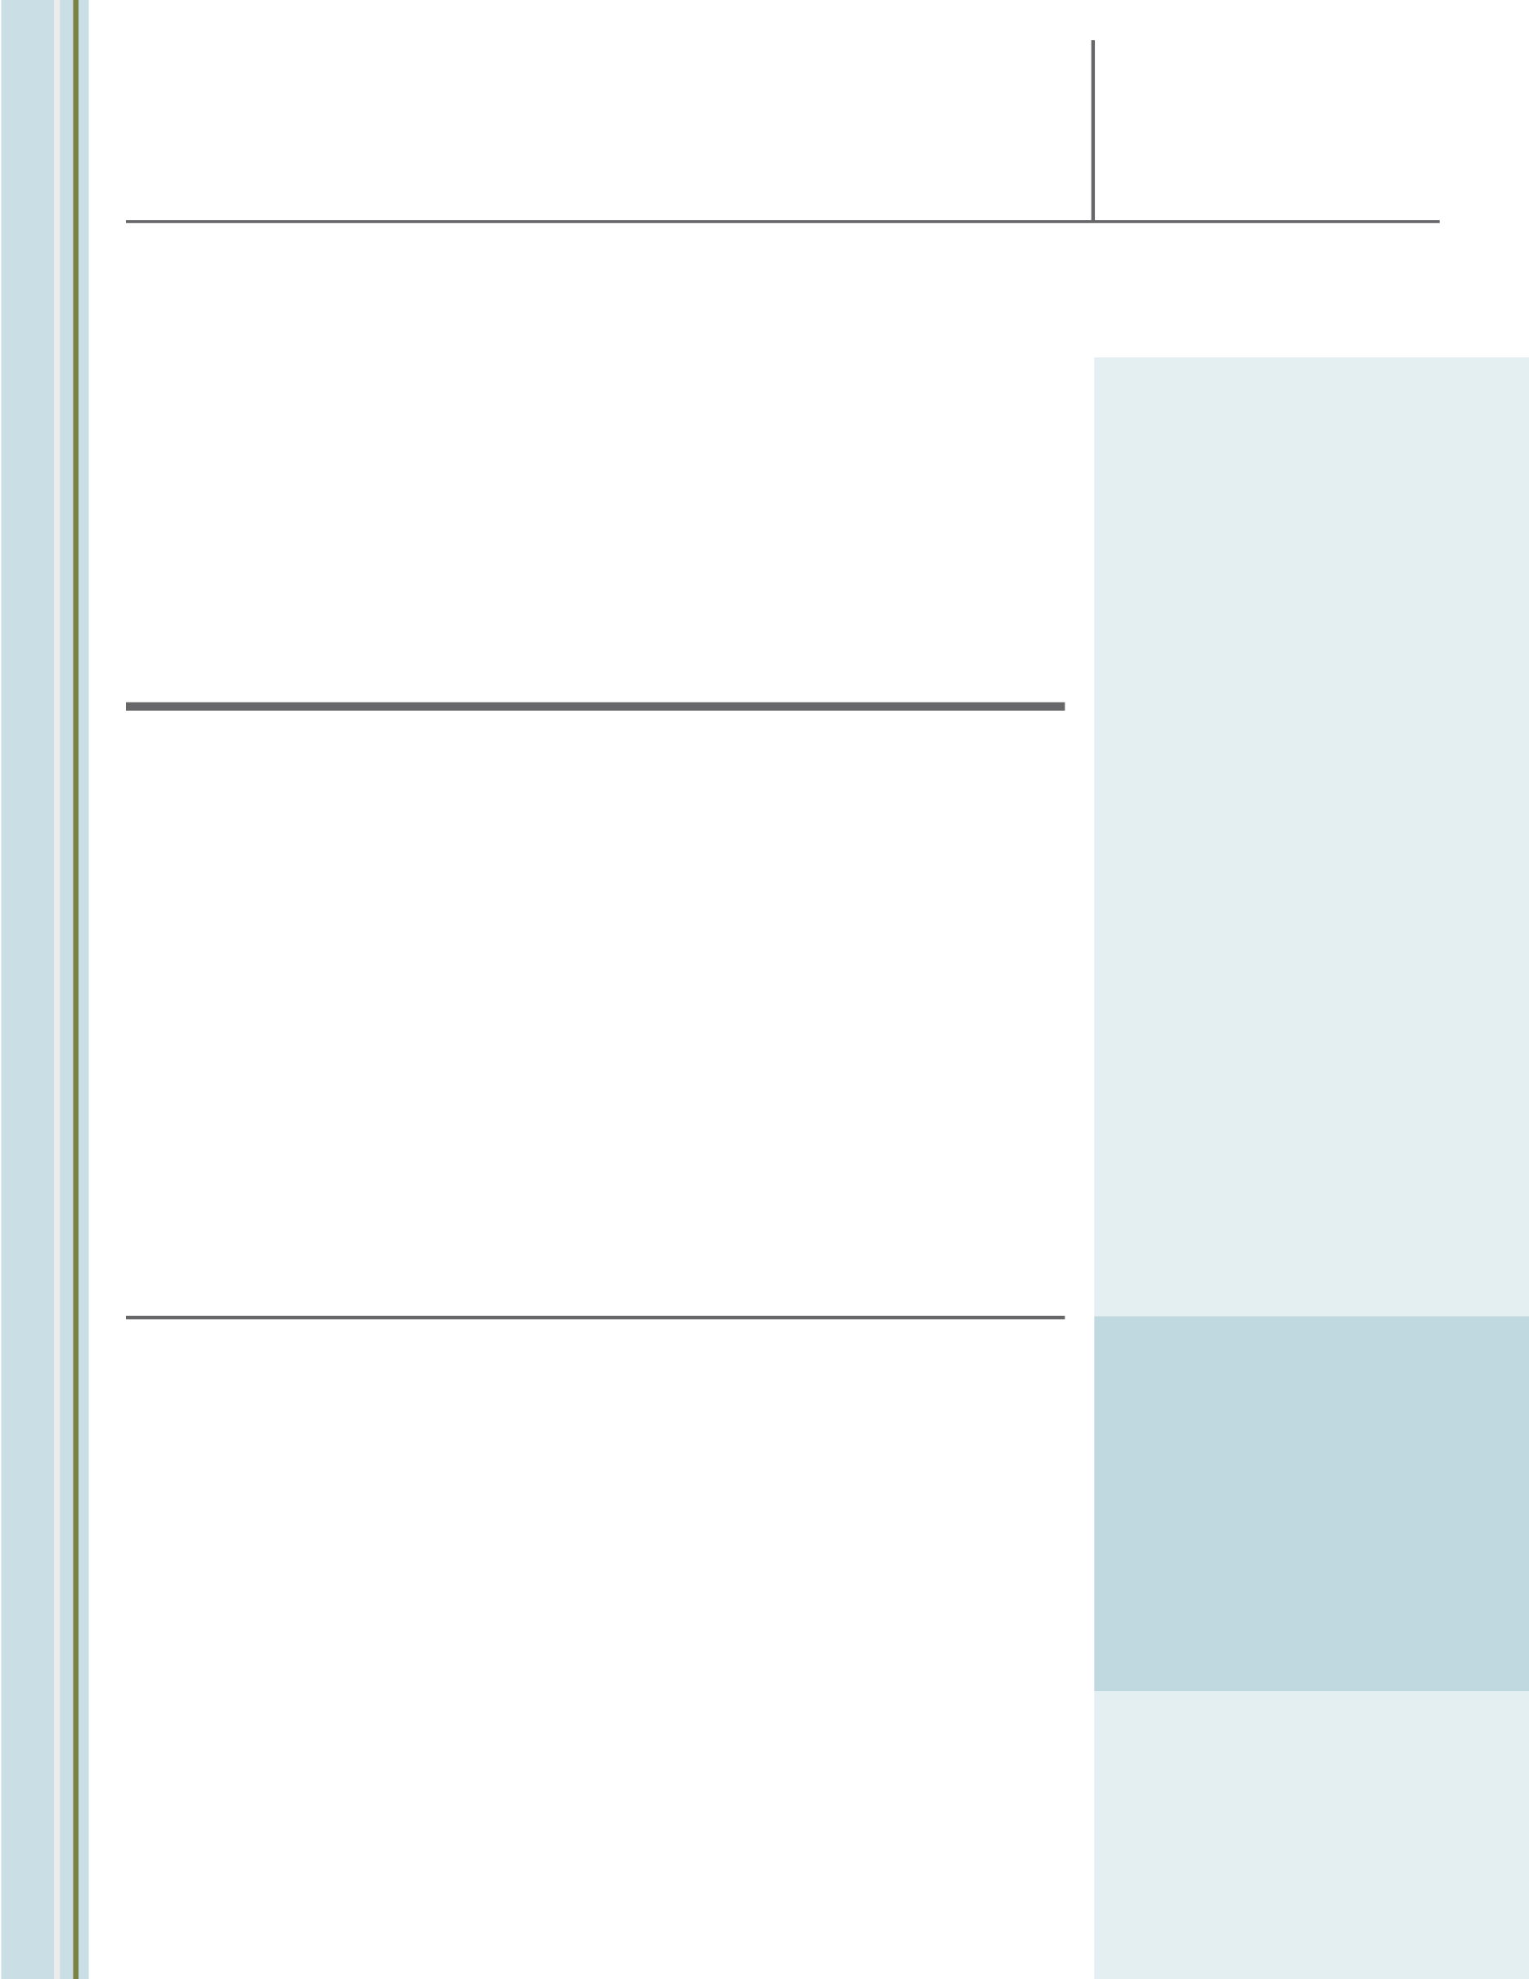

Your logo and project partner logos here.

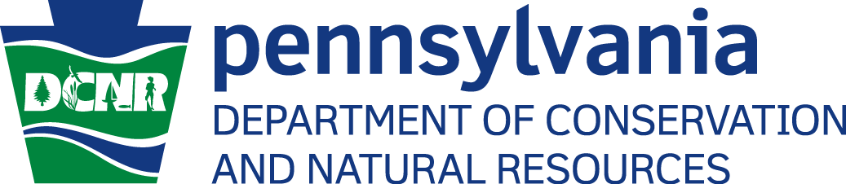

**FUNDING**

**Grant Award:**

**Total Project Cost:**

**PARTNERSHIP IS KEY**

**Please list any partnerships and their contribution to your project - Approximate length: maximum 550 characters and spaces allowed, Ariel 10 point bold**

PLEASE INSERT PHOTO TO REPLACE THIS PHOTO PLACEHOLDER WITH A PHOTO THAT BEST REPRESENTS YOUR SPECIFIC PROJECT.

Organization Name Here

SUCCESS STORY

**CHALLENGE**

Please explain why the project was necessary and what need was addressed in your community through this project - Approximate length: maximum 1,075 characters and spaces allowed Ariel 10 point.

**SUMMARY**

Brief Summary of Project - Approximate length: maximum 645 characters and spaces allowed Ariel 11 point.

**The Project’s Name Here**

By: Your Organization

Insert additional picture here if desired.

**RESULTS**

If quantifiable please include statistics/If qualitative, please include observations, quotes, etc. - Approximate length: maximum 1,280 characters and spaces allowed Ariel 10 point.

**SOLUTION**

How your project filled this need - Approximate length: maximum 750 characters and spaces allowed Ariel 10 point.

**Contact**

**Insert pertinent contact information for your organization, mini-grantee, or both.**

Place additional photo(s) here – 4 photos maximum (i.e. before, during, after photos)